
Week 5 Homework: Grade 1 Science
Name: ………………………………
Class: ………………………………

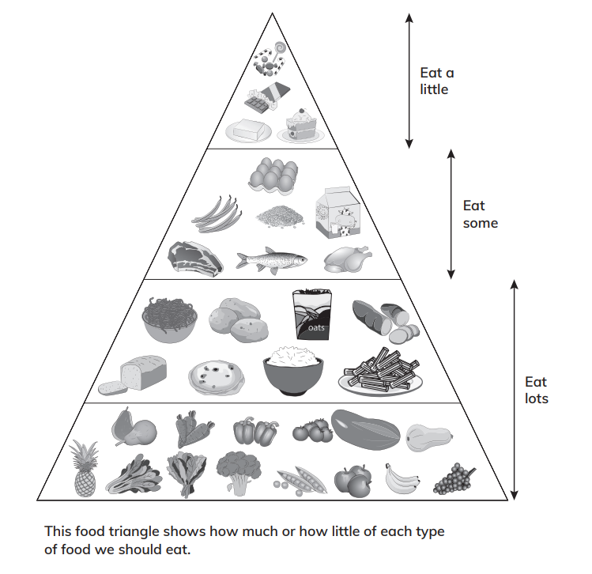
- Food Groups

Tell whether you eat lots, eat some, or eat a little. The first one has been done for you.
eat some

- milk - _________________
- rice - _________________
- banana - __________________
- eggplant- _________________
- pork - _________________
- fish - _________________
- candy - _________________
- bread - _________________
- avocado - _________________
- cake - _________________

- Read and answer the questions below.

- Which of these is an exercise? Circle your answer.

swimming
running
sleeping
playing basketball
reading
jogging

- Why should we wash our hands before eating?
_____________________________________________________________________
- What part of our body gets stronger when we exercise?
_____________________________________________________________________
- Draw and label your healthy meal here.
